**TABLE OF SPECIFICATIONS FOR EXAM QUESTIONS**

**University of Liberal Arts Bangladesh**

**Department: Computer Science and Engineering (CSE)**

**Midterm Examinations, Semester: Fall 2020**

**Program: B.Sc. in CSE**

**Course Code: CSE480 Course Title: Web Technology Credit Hr: 3**

**Time: 1 Hours Total Marks: 25**

**Name & Designation of the Examiner: Satyaki Das, Lecturer**

**Learning Outcomes (LO):**

|  |
| --- |
| 1. **Recognize, recall** and **understand** latest practices and performance implications of client-side languages |
| 1. **Understand** and **outline** different processes for transmitting data |
| 1. **Design** and **develop** real-life Web Application |
| 1. **Use** available libraries, APIs and functions in Client-Side Language |
| 1. **Possess** positive approach to adapting and learning new languages/features and **apply** them to **create** interactive Web Applications |

***Levels in Bloom’s Cognitive Domain:***

***C1: Remember C2: Understand C3: Apply C4: Analyze C5: Evaluate C6: Create***

|  |  |  |  |  |  |  |  |
| --- | --- | --- | --- | --- | --- | --- | --- |
| **Question No.** | **Learning Outcomes (CO)** | **Level in Bloom’s Cognitive Domain along with Allocation of Marks** | | | | | |
|  |  | **C1** | **C2** | **C3** | **C4** | **C5** | **C6** |
| 1 | 1 | 2 | 3 |  |  |  |  |
| 2 | 1 |  |  | 5 |  |  |  |
| 3 | 3 |  |  | 10 |  |  |  |
| 4 | 1 |  | 5 |  |  |  |  |
| **Total Allocation of Marks** | **25** | 2 | 8 | 15 |  |  |  |
|  |  |  |  |  |  |  |  |
| **Question No.** |  | **Learning Outcome** | | | | | |
|  |  | **CO1** | **CO2** | **CO3** | **CO4** | **CO5** | **CO6** |
| 1 |  | 5 |  |  |  |  |  |
| 2 |  | 5 |  |  |  |  |  |
| 3 |  |  |  | 10 |  |  |  |
| 4 |  | 5 |  |  |  |  |  |
| **Total Allocation of Marks** | **25** | 15 |  | 10 |  |  |  |



**Signature of the Examiner Date: 23.11.2020**

**Department of Computer Science and Engineering**

**University of Liberal Arts Bangladesh**

**Mid-Term Examination (Fall 2020)**

**Course: Web Technology (CSE 480)**

**Section: 1 --- Duration: 1 Hour**

**Name & Designation of the Examiner: Satyaki Das, Lecturer**

**______________________________________________________________________________________**

**PLEASE ANSWER ALL QUESTIONS. Total 25 Marks**

**QUESTION 1**

Briefly Describe the role of HTML, CSS and Javascript in Web Development. Why do we use the “meta” tag? “An HTML document follows a tree structure.” – Explain **(2+1+2=5 Marks)**

**QUESTION 2**

Consider the following webpage:

This is a random text with custom

lines and spaces ……

Write the HTML code required to create a webpage with this content. **(5 Marks)**

**QUESTION 3**

Write the HTML & CSS code required for the following webpage content:

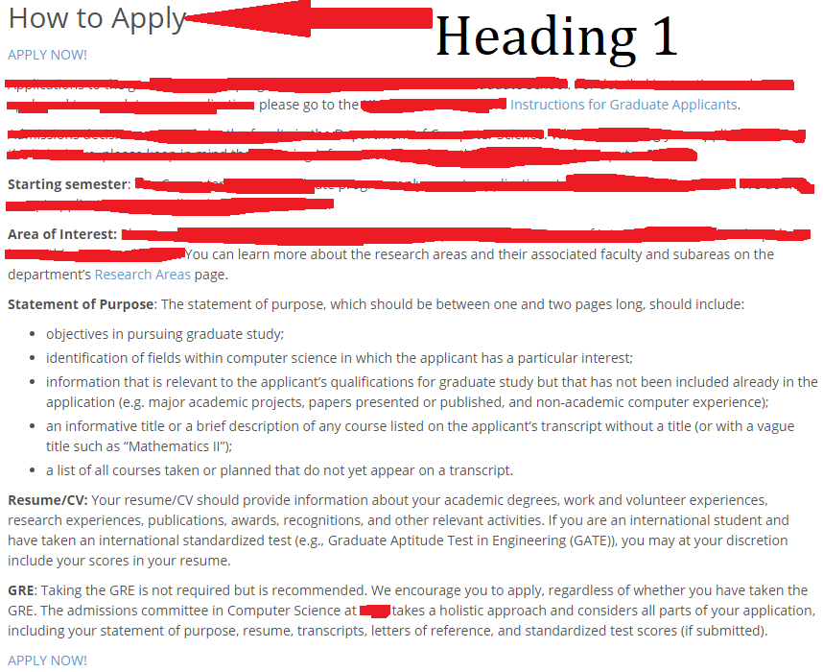

All the text except the first heading will follow paragraph style. Use anchors for links to other websites. You don’t have to provide an actual link in the anchors (i.e., you can use href=”#”). Use any font of your choice. Use arbitrary content in censored-areas of the image. **(10 Marks)**

**QUESTION 4**

Describe the different ways to specify “padding” with proper examples. What is the usage of z-index in CSS? **(3+2=5 Marks)**

**\*\*END OF QUESTIONS\*\***